Video Conference with Zoom at UPC
This is a short “tutorial” prepared by Elisabet Mas (Eng. Nuclear - Dept. Fisica - ETSEIB). It has been written in a very short time just to help as a “getting started” document.

Account activation
Connect to https://www.zoom.us/

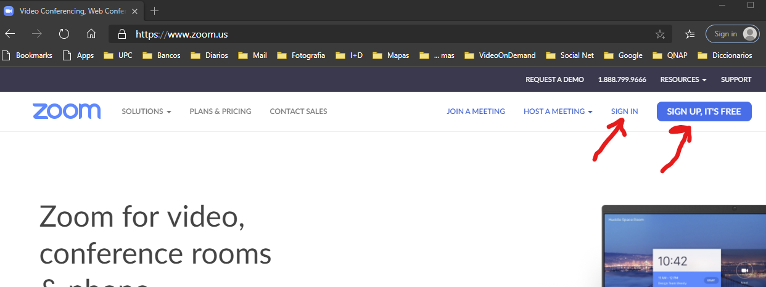

If you would like to use your e-mail (ie, upc.edu, private, …) follow the Sign-up link. A confirmation e-mail will be sent shortly after. Follow the activation link included in the message. We would recommend activating your upc.edu account.

Google accounts can be used to Sign-In without the Sign-up+Activation steps..
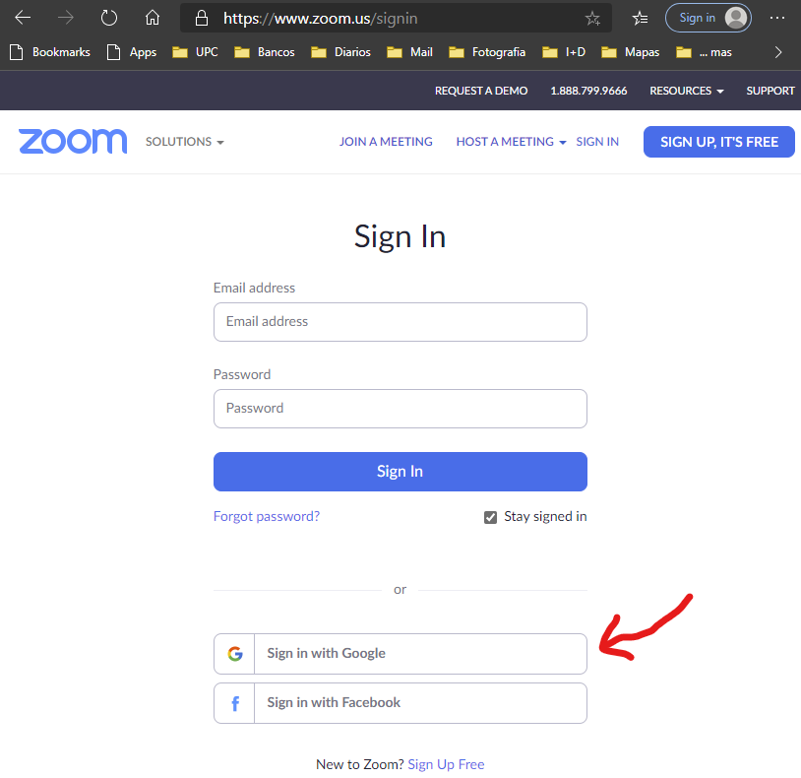

Scheduling a meeting
Multi-user meetings are limited to 40 min. But, this limitation seems to have been removed, temporarily, due to the Covid emergency.

One you're logged in, go to HOST A MEETING and click on With Video On:

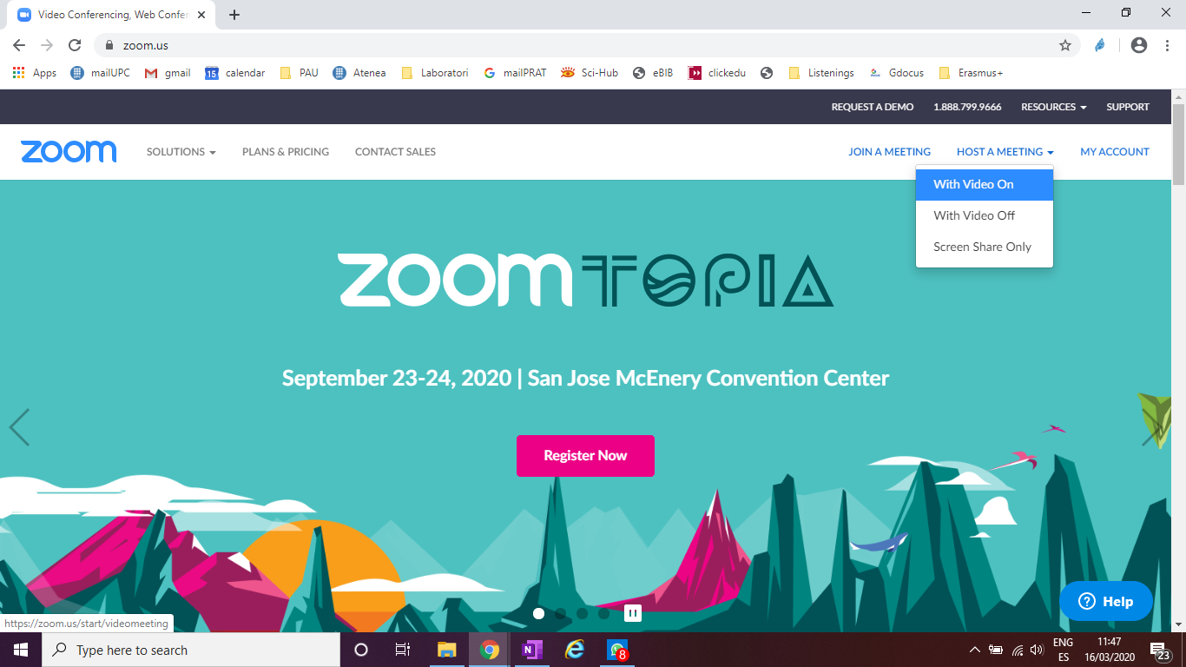
In your first meeting, a message appears asking if you to Install and run Zoom.
Otherwise, a message informs you to open Zoom. Accept the opening.

Note: Meeting can be hosted/attended without installing Zoom. After the “Install and run ..” press the “click here” link, and choose “start from your browser”
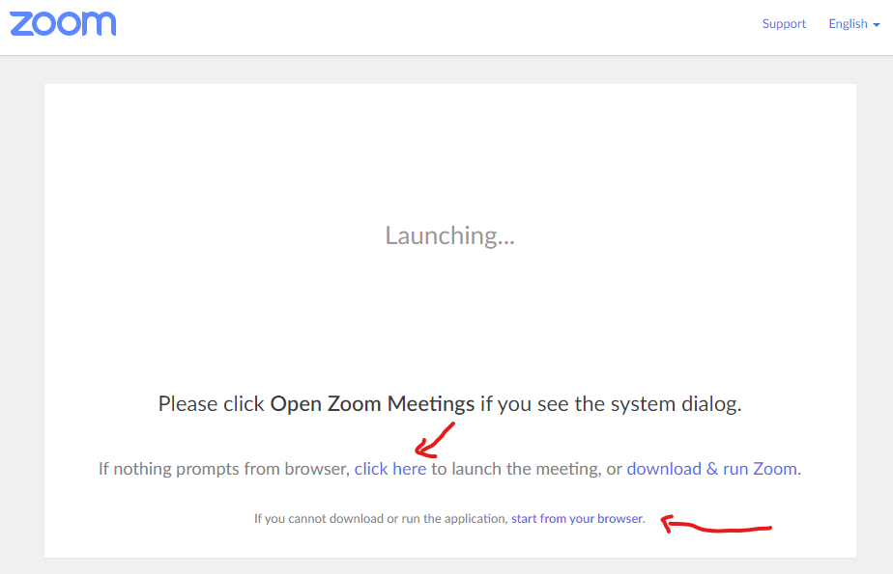

A second message appears regarding the activation of the audio. Accept and proceed.
If a meeting has opened automatically, just close it.
You should see this window:
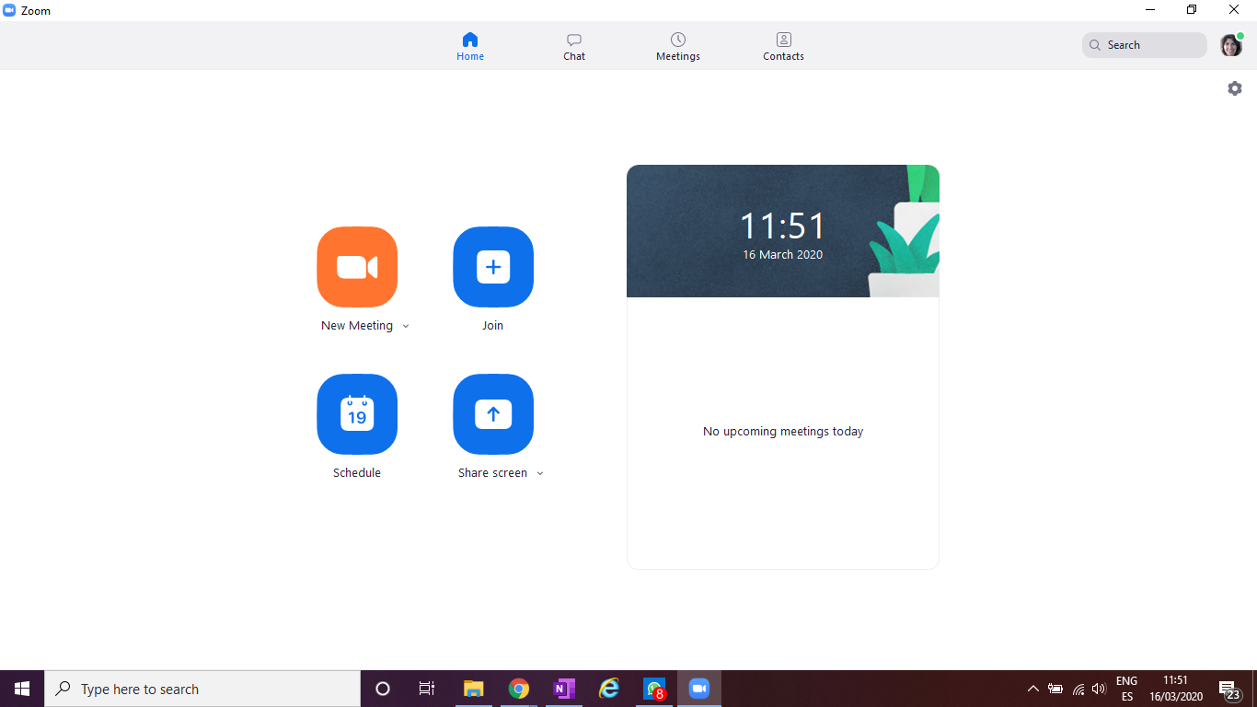

Click on Schedule and fill the form.
Note that:
- You DO need to modify the topic (i.e. Session #1)
- You DO need to modify the start and duration of the conference.
- You DON’T need to modify anything about the meeting ID or password.
- You should activate the video of the Host (you)
- You can activate the video of the participants
- The meeting can be seen in your Calendar

Once everything is correctly filled up, click on Schedule.
You will be redirected to Google Calendar (and your UPC credentials will be asked again)
On the right of the screen you will be able to include the list of participants

Once saved, the conference is available on each participant’s Calendar.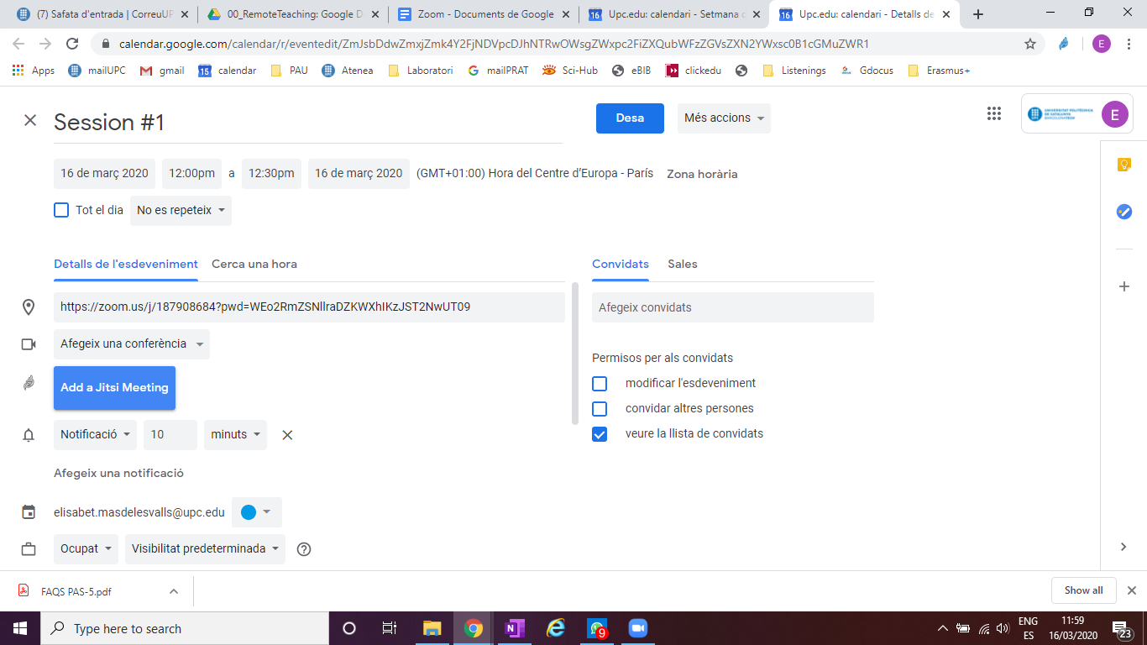
Participants will need to click on the scheduled conference in their Calendar. They will be automatically asked to download Zoom (the first time) and enable the video and sound utilities. After these two steps, they will be in.

Video Conference features
- The Host can control the voice and camera of all participants
- The Host can record the session. If done, an MP4 file is generated. AT the end of the recording, the application asks where to save the file.
- Participants can rise hand
- Participants have no control on other’s set up (voice and camera) and cannot record the session
- All, the Host and participants, can share screen
- When sharing the screen, several features are available: the full Desktop, a specific open window, part of a window or a whiteboard.
- There’s a chat where everybody can write and upload files.

